What’s For Dinner?:
Ham and Swiss Cheese Potato Bake
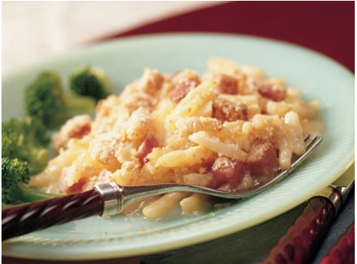
1. Preheat oven to 400 degrees. Spray baking dish with oil.
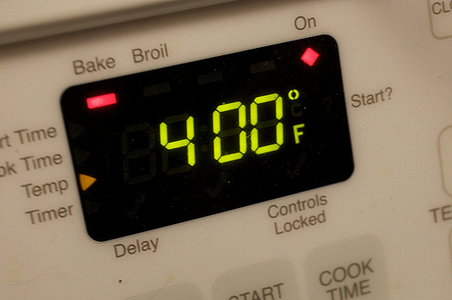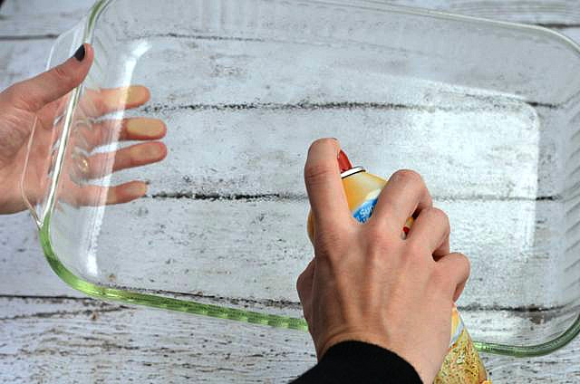
2. Open hash browns and pour into baking dish.
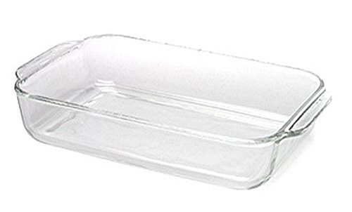
3. Add ½ box of milk and can of soup. Mix.

3. Add diced ham and mix.
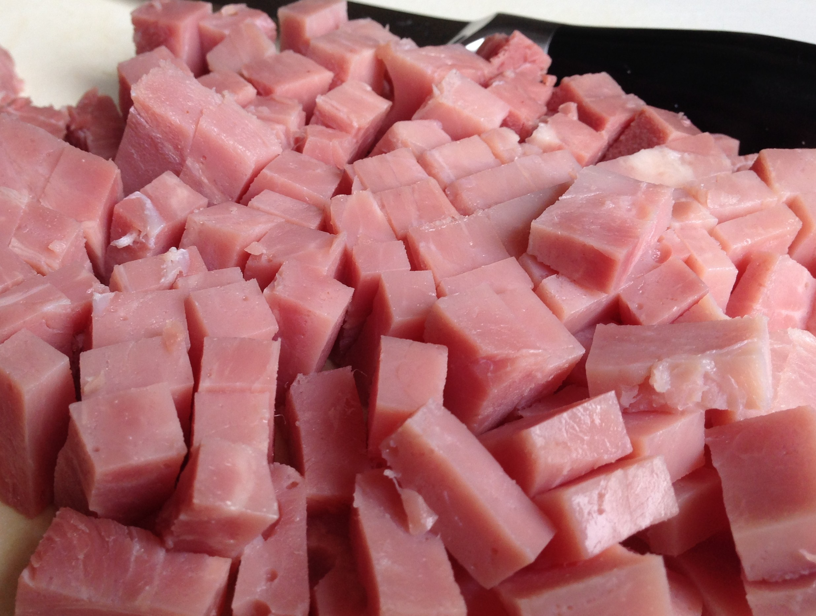
4. Add cheese. Mix.
5. Sprinkle bread crumbs across the top of the baking pan.
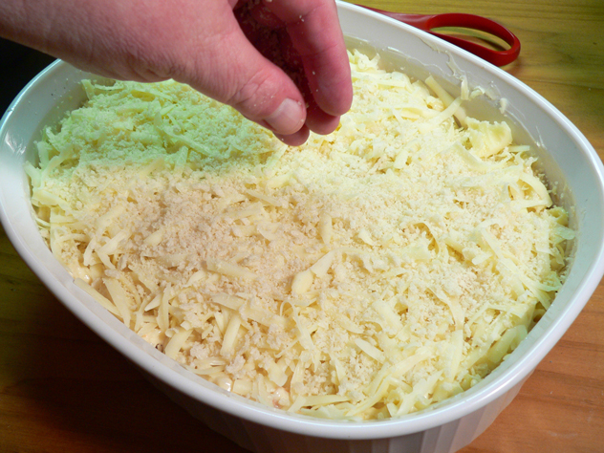

6. Bake uncovered for 50 minutes or until the top is golden brown.

