What’s For Dinner: Oven Stewed Chicken
Supporting Materials
Original Recipe:

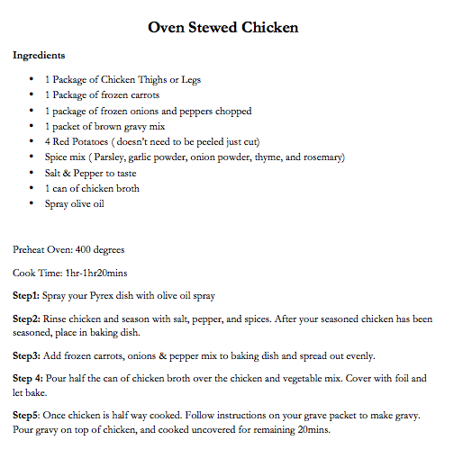

Equipment Needed:

- Oven
- Scissors to open packages
- Can opener
- 2 quart baking pan
- spoon
- disposable gloves (to handle raw chicken)
- aluminum foil (to cover pan)

Notes:.
- Some individuals will have difficulty opening packages with scissors; this might have to be done for them or with them.
- Can openers can often be difficult to use. You might want to set up the can opener and have the individual with disability do the turning.
- It is important that gloves be worn while handling raw meat.
- Some individuals will have difficulty holding the spray nozzle down when greasing the pan; use hand-over-hand to help them learn the motion.
- It might be difficult for the individual to stir ingredients within the pan; assistance may be required.

