**What’s For Dinner: Meatloaf**

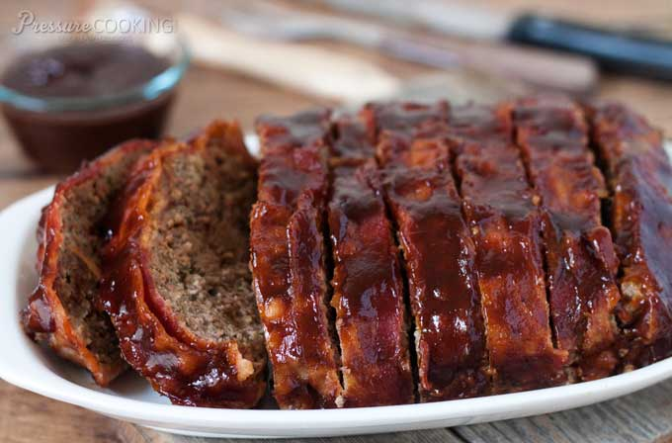

Shopping List:

|  |  |
| --- | --- |
| AMOUNT | ITEM |
| 2 | pounds ground beef |
| 1 | box chicken flavored stuffing |
| 2 | eggs |
| 1 | bottle barbeque sauce (28 oz.) |
| 1 | bag of frozen peppers/onions |
| 1 | bottle spray oil |
|  | gloves |