What’s For Dinner: Barbeque Chicken Casserole
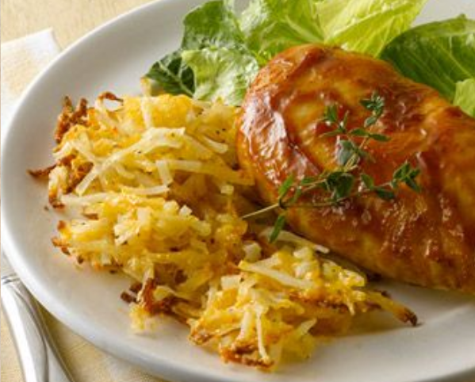
1. Heat oven to 400 degrees. Spray baking dish.
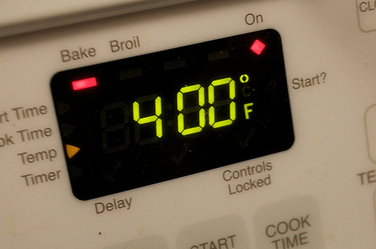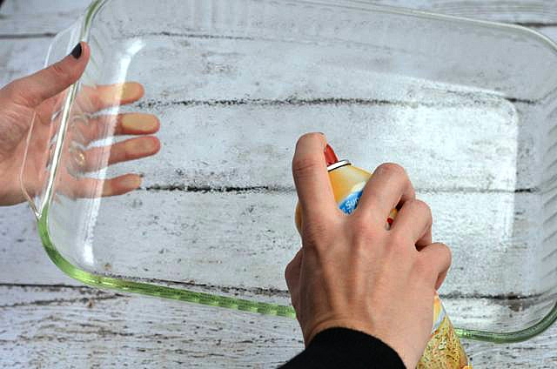
2. Put potatoes and cheese in baking dish.
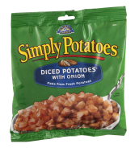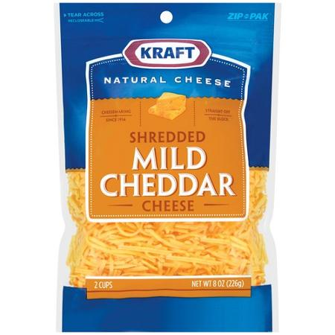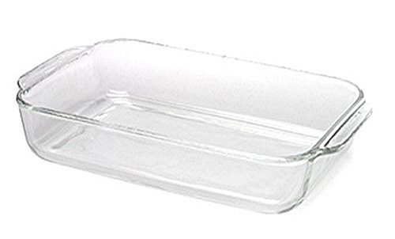
3. Spray the ingredients in the pan with oil. Then stir to mix well.
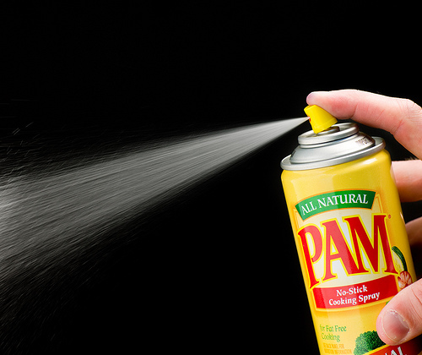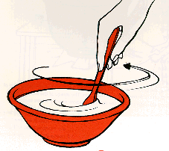

4. Lay chicken breasts across the top of the potato mixture.

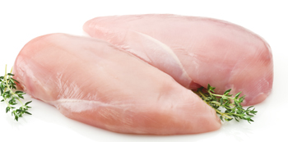
5. Pour ½ bottle barbeque sauce over chicken.
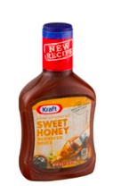

6. Bake 40 minutes or until potatoes are golden brown. Serve remaining barbeque sauce on side.
