What’s For Dinner: Lasagna Alfredo
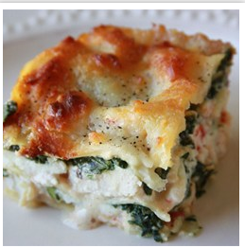
Shopping List:
AMOUNT | ITEM
1 | 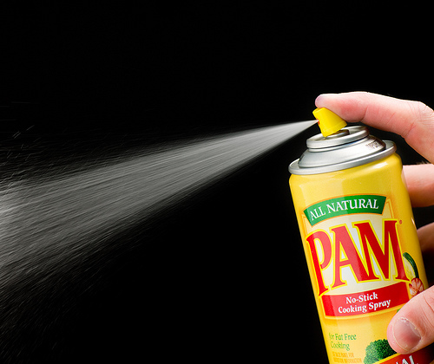  can spray oil
1 | 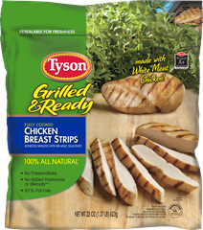  package cooked chicken
1 | 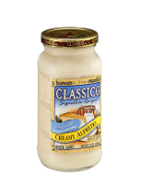  jar light alfredo sauce
1 | 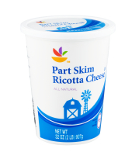  8 oz. container part skim ricotta cheese
1 | 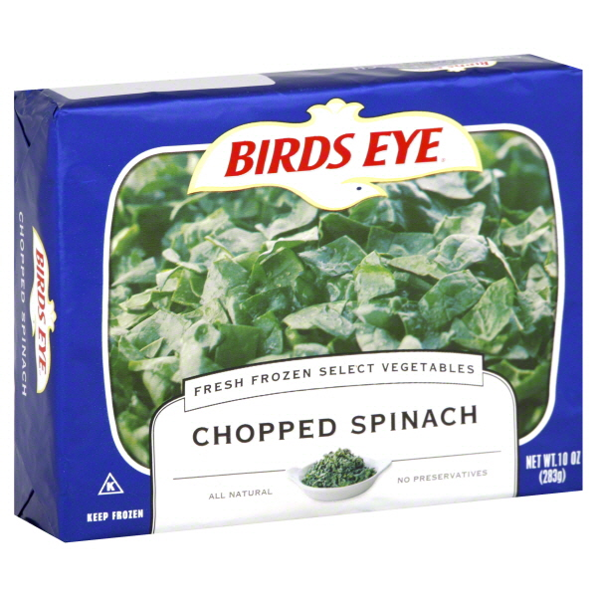  1 package chopped spinach (thawed)
1 | 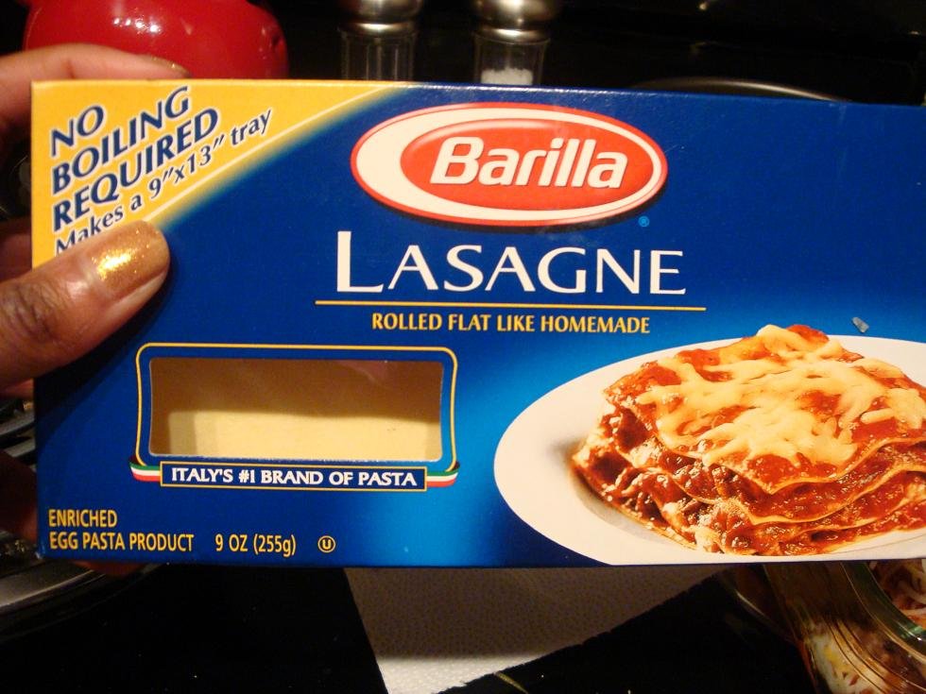  1 package no cook lasagna noodles
1 | 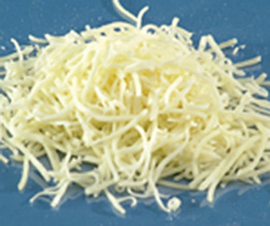  8 oz. package mozzarella cheese
1 | 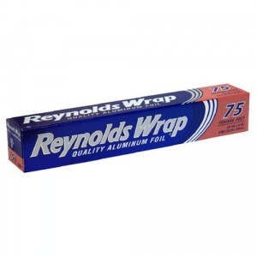  roll of aluminum foil

