**What’s For Dinner: Rice Chicken Wraps**

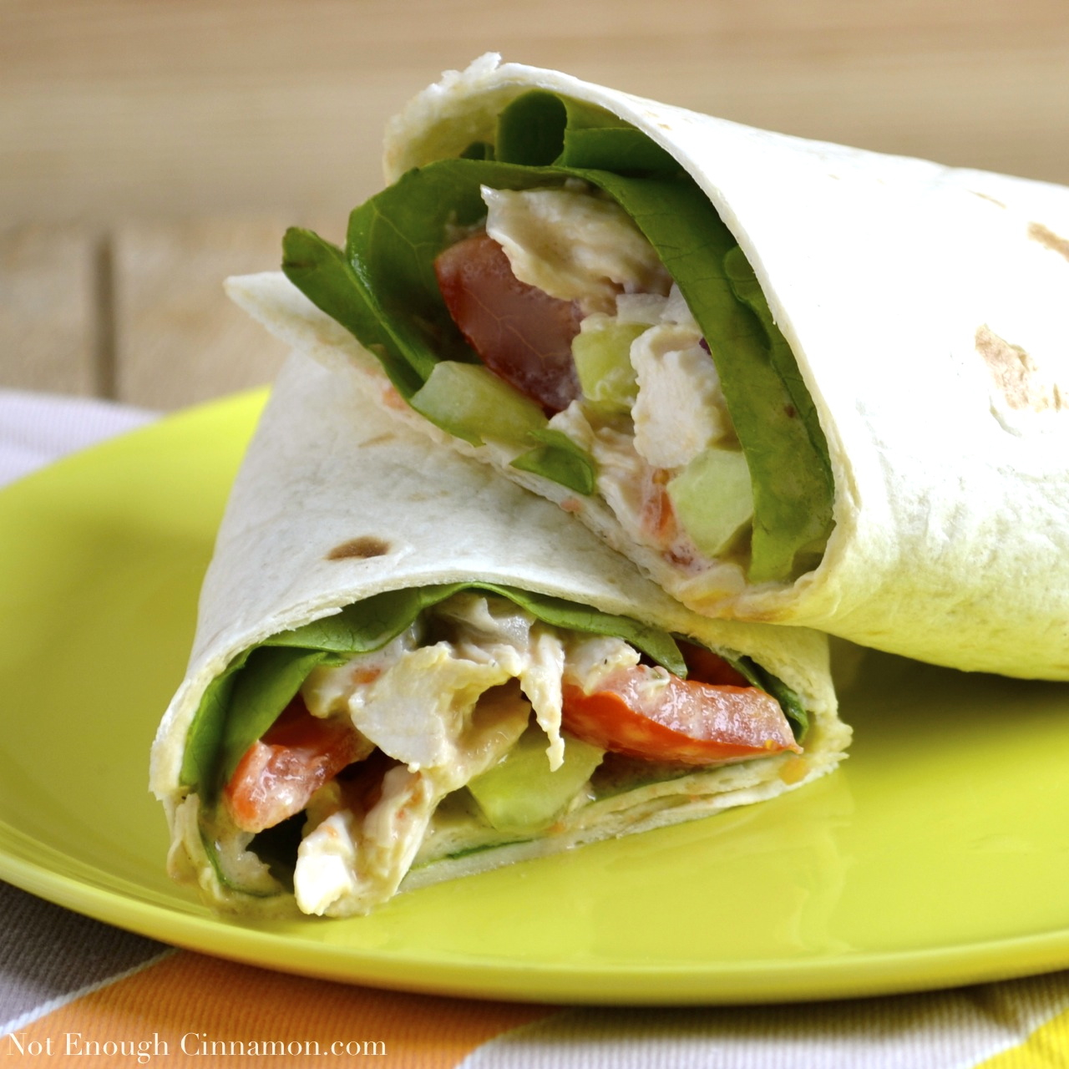

Shopping List:

|  |  |
| --- | --- |
| AMOUNT | ITEM |
| 1 | package Uncle Ben’s Microwaveable Wild Rice |
| 1 | package cooked chicken |
| 1 | bottle Caesar dressing |
| 4 | flour tortillas |
| 1 | tomato |
| 1 | 1 package spring mix |