What’s For Dinner?:
Oven Roasted Pork Chops with Vegetables
Supporting Materials

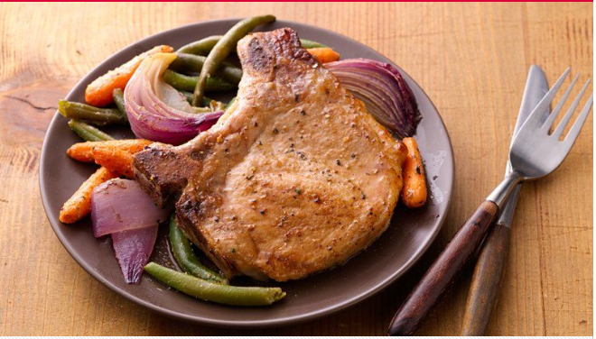

Original Recipe:
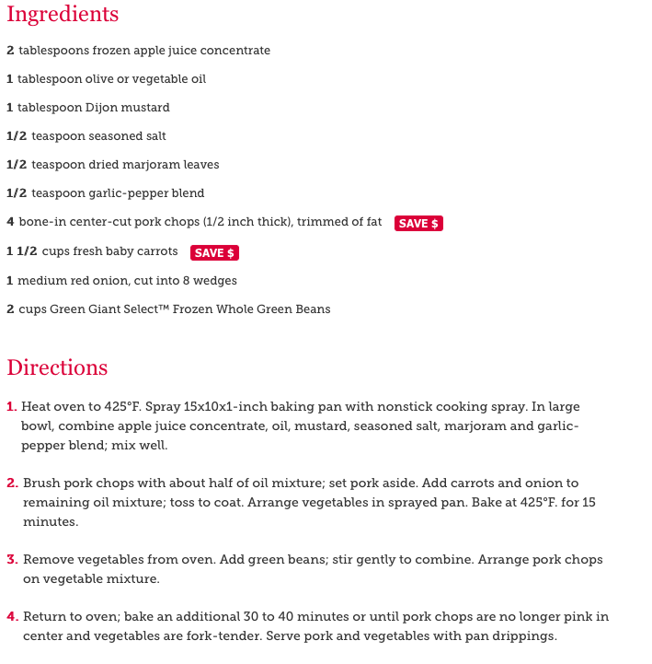

Equipment Needed:

- oven
- scissors (to open frozen vegetables)
- 2 quart baking pan
- spoon
- basting brush
- disposable gloves (to handle raw meat)

Notes:.
- Some individuals will have difficulty opening vegetables with scissors; this might have to be done for them or with them.
- It is important that gloves be worn while handling raw meat. After this step, the gloves should be taken off and thrown away to prevent the spread of any bacteria. Once thrown away, the individual should wash their hands and proceed with the recipe.
- Always check the meat after removal from the oven to ensure that it is cooked properly throughout.
- Some individuals will have difficulty holding the spray nozzle down when greasing the pan; use hand-over-hand to help them learn the motion.
- It is important to baste both sides of the pork chops; turn them over with a fork.

