What’s For Dinner?: Oven Roasted Pork Chops with Vegetables
If you don’t have a large enough baking pan for all of the pork chops, use 2 smaller baking pans.

1. Heat oven to 425 degrees.
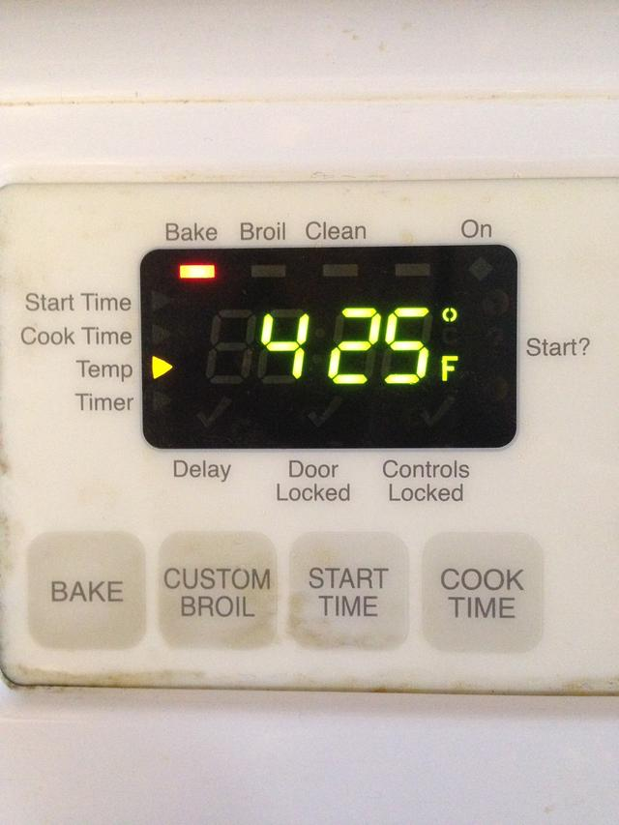
2. Spray baking pan.
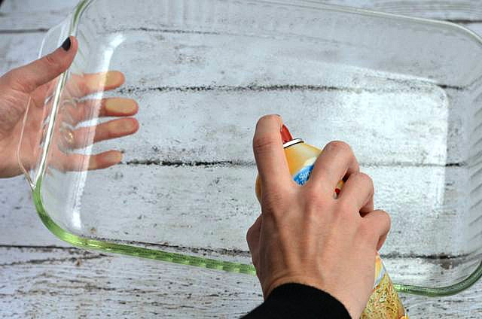
3. Brush pork chops with sauce. Do both sides. Arrange in baking pan.
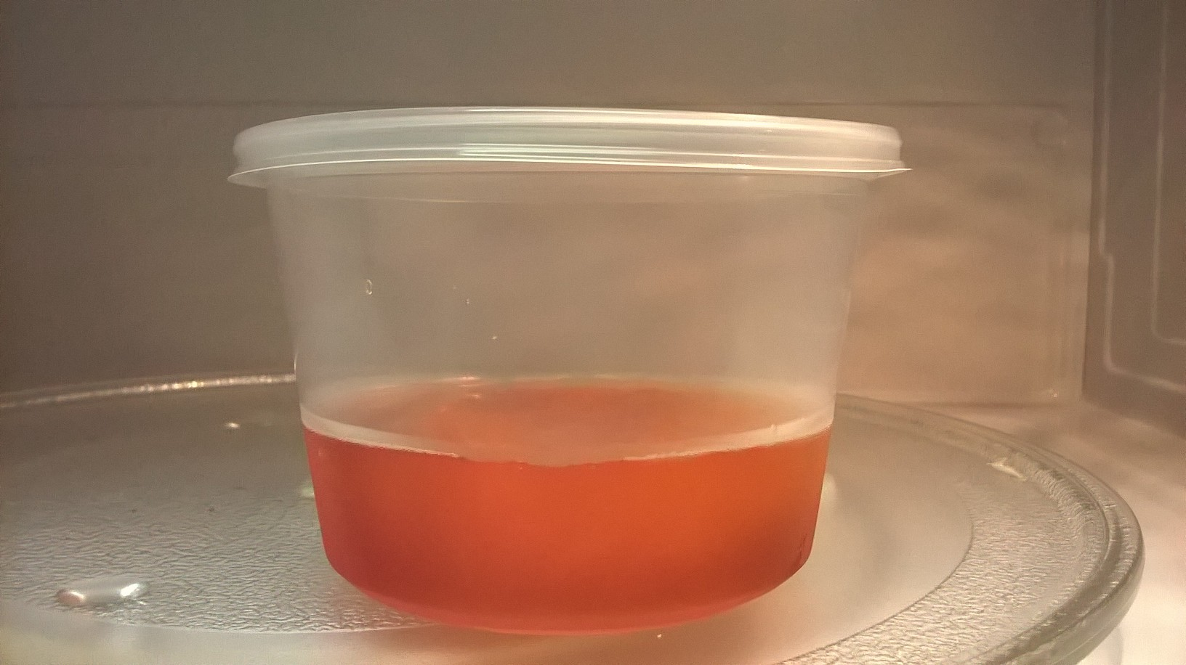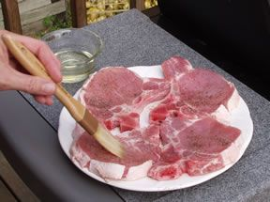

4. Remove skin and chop onion.
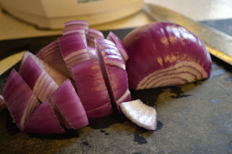
5. Add onion, carrots and green beans to pan and arrange around pork chops.
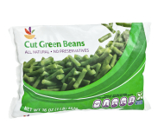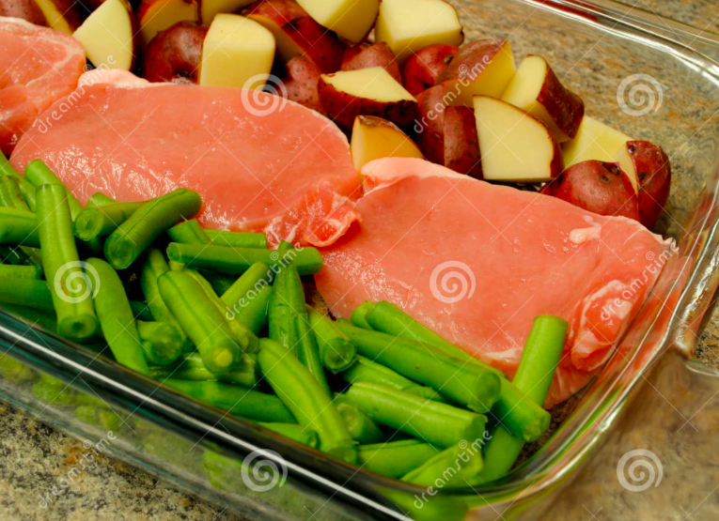

6. Pour remaining sauce over the baking pan.
7. Bake for 50 minutes uncovered. Serve with the pan juices.

