What’s For Dinner: Oven Stewed Chicken
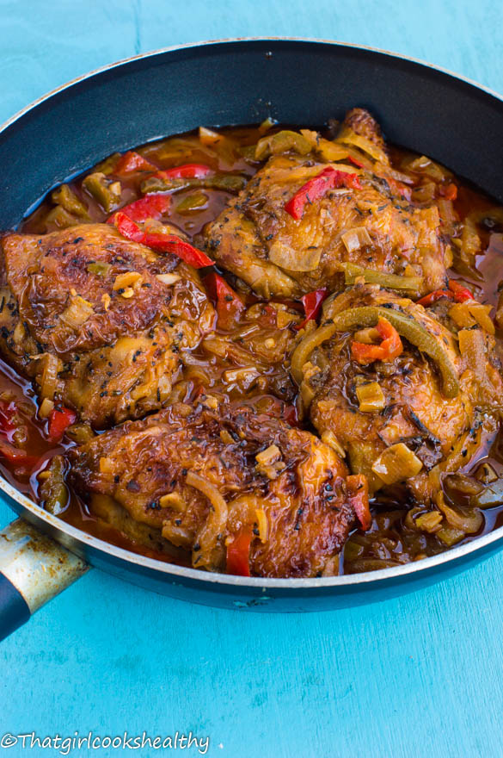
Shopping List:
AMOUNT | ITEM
1 | 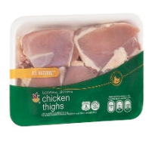  2 ½ pounds chicken thighs
1 | package frozen carrots
1 | 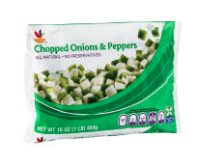  package frozen peppers and onions
1 | 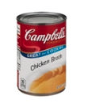  10 oz. can chicken broth
1 | 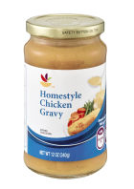  jar chicken gravy
 | spray oil to grease pan
 | Aluminum foil to cover pan
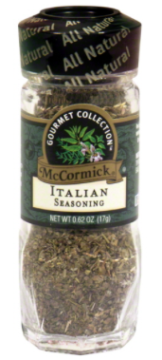
Salt, pepper, parsley, garlic powder, onion powder, thyme and rosemary.

See original recipe in supporting materials for amounts

