**What’s For Dinner: Herb Baked Salmon**

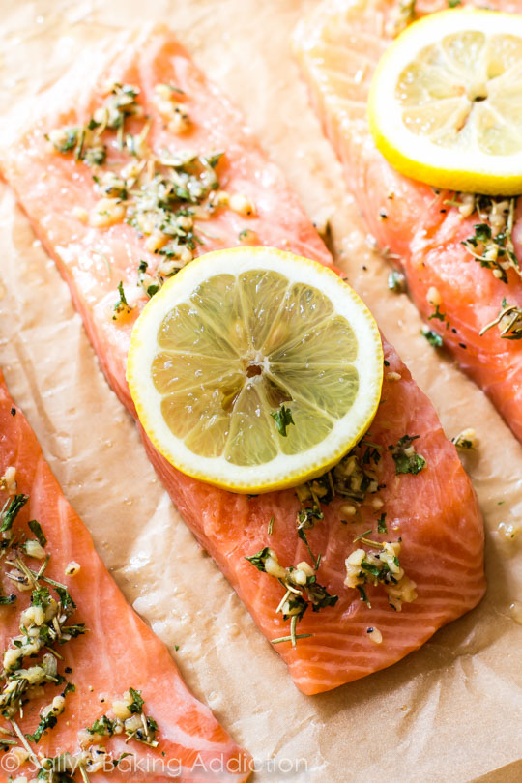

Shopping List:

|  |  |
| --- | --- |
| AMOUNT | ITEM |
| 1 | http://kingofwallpapers.com/lemon/lemon-016.jpg  Lemon |
| 1 | McCormick Italian Seasoning, 0.75 oz  bottle italian seasoning |
| 1 | https://www.freshdirect.com/media/images/product/seafood/fish_fillets/fflt_slmn_fa_flt_z.jpg?lastModify=2009-03-16  Salmon Fillet |
| 1 | roll aluminum foil |
| 1 | can spray oil |