What’s For Dinner: Chicken Parmesan Casserole
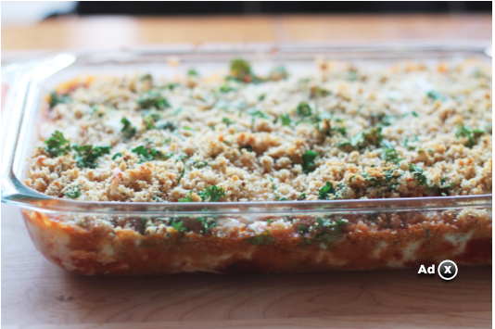
Shopping List:
AMOUNT | ITEM
1 | 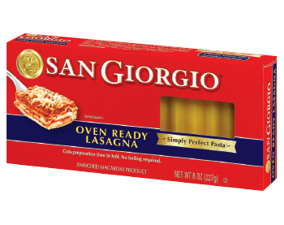  package oven-ready lasagna noodles
1 | 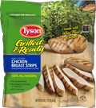  package chicken strips
1 | 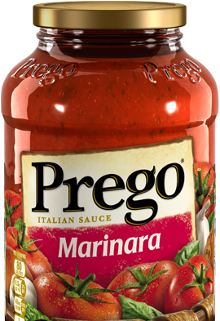  28 oz. jar marinara sauce
1 | 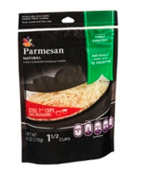  8 oz. package parmesan cheese
1 | 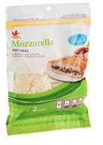  8 oz. package mozzarella cheese
1 | 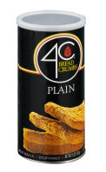  1 cup bread crumbs
1 | 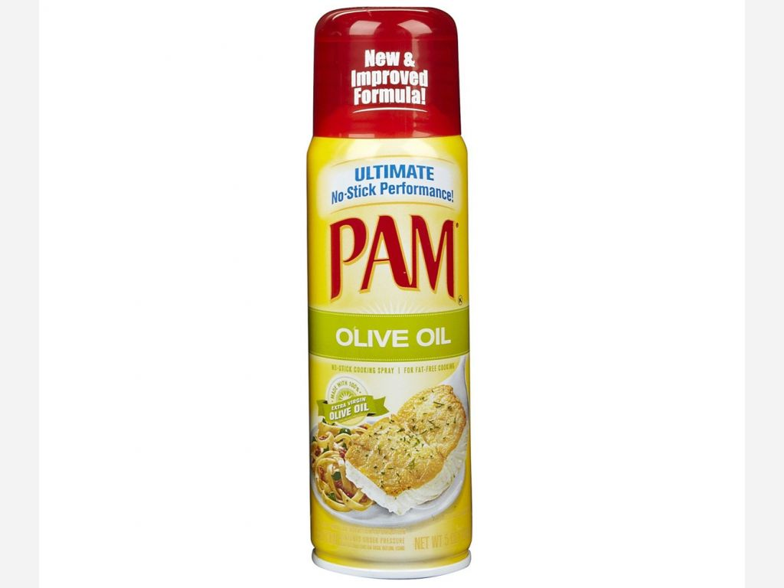  1 can spray oil
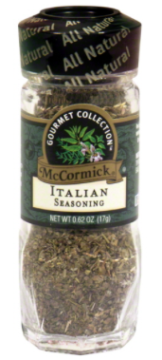
Salt, pepper, italian seasoning in small amounts.

See original recipe in supporting materials.

