What’s For Dinner: Lasagna Alfredo
Supporting Materials
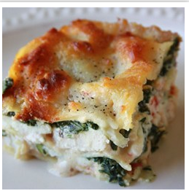

Original Recipe:
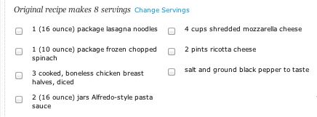

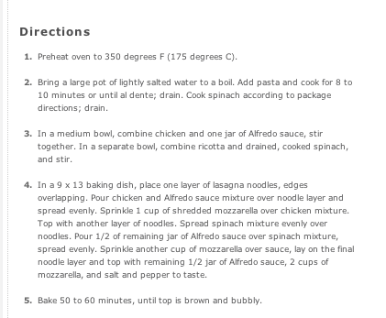

Equipment Needed:

- oven
- scissors (to open chicken, cheese)
- 2 quart baking pan
- 2 bowls
- spoon
- 1 Cup Measuring cup
- aluminum foil
- spray oil

Notes:

- It is best to buy the cheese already shredded for ease of production. A variety of different cheeses can be used with this recipe.
- Some individuals will have difficulty opening the chicken or cheese with scissors; this might have to be done for them or with them.
- Let the spinach thaw before using in the recipe.
- Some individuals will have difficulty in understanding how to use half of the jar of alfredo sauce. Talk them through this process and offer visual clues.
- Some individuals will have difficulty with spreading the cheese– this can often result in uneven distribution. Help them move slowly throw this procedure and emphasize even distribution.
- Some individuals will have difficulty holding the spray nozzle down when greasing the pan; use hand-over-hand to help them learn the motion.

