What’s For Dinner: Oven Stewed Chicken
1. Heat oven to 400 degrees.
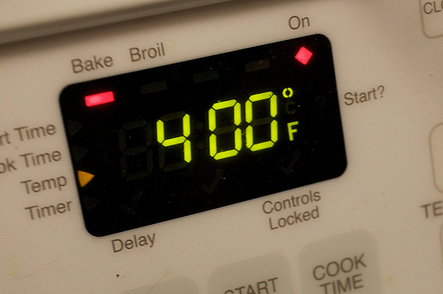
2. Spray baking pan.
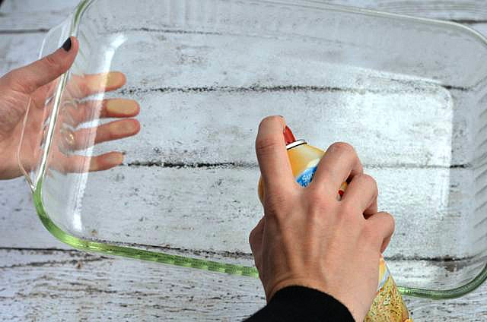
3. Wearing gloves, put chicken parts in pan and sprinkle with seasoning packet.
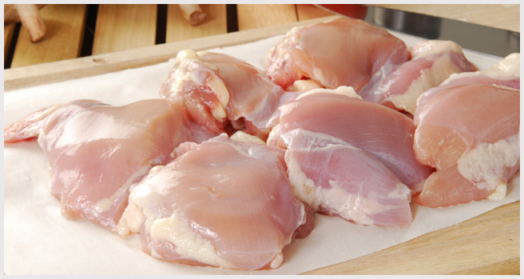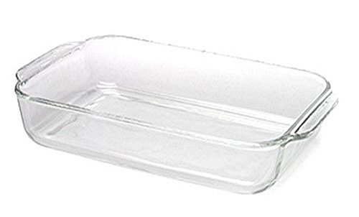
4. Add carrots and onion/pepper mix to pan and spread evenly.
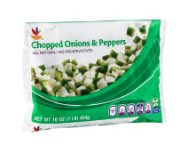

5. Open chicken broth with can-opener and pour over dish. Cover with aluminum foil.
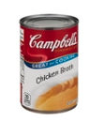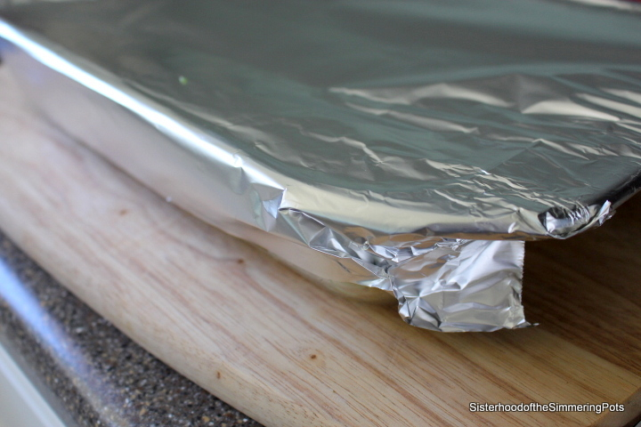
6. Put the dish in the oven and let cook for 45 minutes. Remove and pour the gravy over the top.
7. Bake UNCOVERED for an additional 15 minutes. Remove from oven. Eat.

15minutes

