**What’s For Dinner: Tuna Casserole**

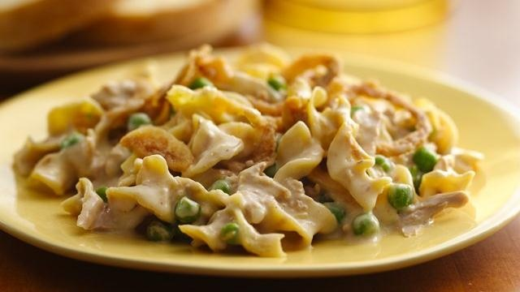

Shopping List:

|  |  |
| --- | --- |
| AMOUNT | ITEM |
| 1 | 12 oz. can of tuna |
| 1 | can of cream of chicken soup |
| 1 | package quick cook elbow macaroni |
| 1 | package frozen peas |
| 1 | cup milk |
| 2 | cups shredded cheese |
| 1 | package fried onions |
|  | Aluminum foil |